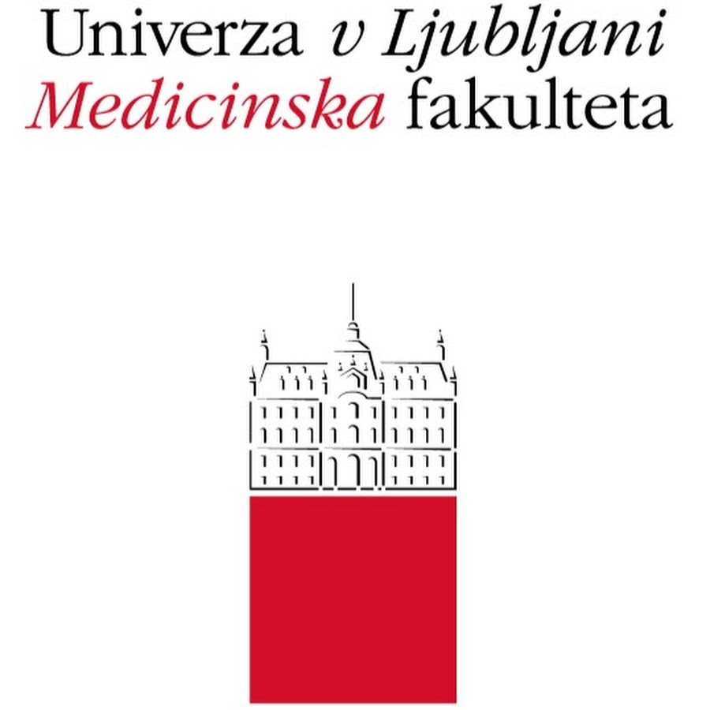

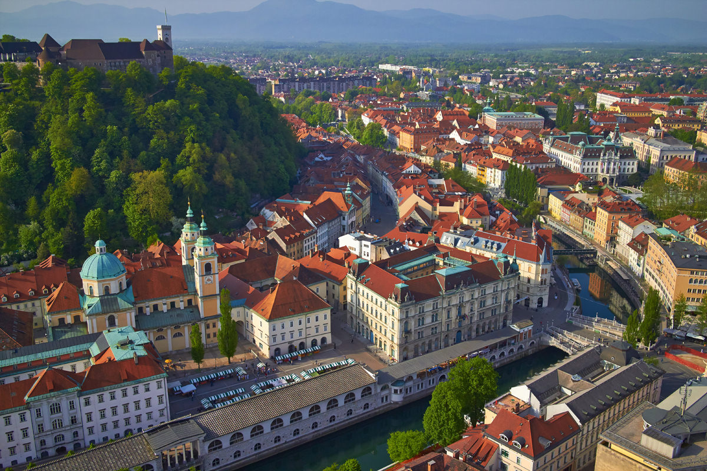

Save the date:
July 2nd–11th, 2018
Ljubljana, Slovenia

________________________________________________________________

Join us for our Summer School
in Primary Care in Ljubljana!

We welcome international students of medicine and health systems to the first summer school of the Faculty of Medicine at the University of Ljubljana in cooperation with the Radboud University Medical Center and the University of Crete:

Cultural Competences,
Doctor-Patient Communication,
and Minority Health

The increase in migration and the general globalization of healthcare has resulted in a need for students and future doctors to be able to communicate effectively, not only in their own language and culture, but also with people with other languages and cultural norms. This has led to the importance of developing cultural competency. It is one of the key features of this program, which examines the extent to which our practice is evidence-based and how culturally determined it is.

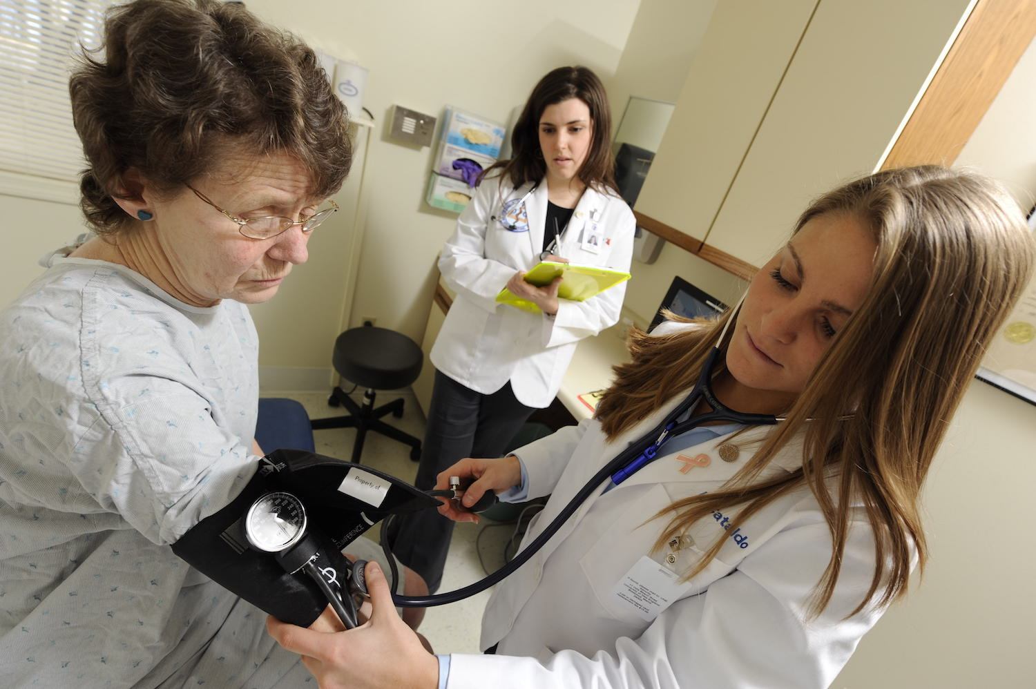

2018 SUMMER SCHOOL
University of Ljubljana,
Faculty of Medicine

______________________________________________________________

Title:
Summer School in Medical Healthcare
(Cultural Competences, Doctor-Patient Communication, and Minority Health)

Certificate: 5 credits

Duration: July 2nd–11th, 2018

Application deadline: April 15th, 2018

Fee: €200

The fee includes refreshments during breaks, bus transport to the Trebnje Roma Center and lunch at the restaurant in Trebnje, and a cinema visit, where there will be a film on cultural competences, especially for students. All of the lunches will be partly reimbursed with the help of the International Office.

______________________________________________________________

Online application: tinyurl.com/yb3n6mwm
A detailed description of the summer school
is available at the website: tinyurl.com/ybo4rl6q

Contact person for registration details:
Jerneja Čelofiga
International Office
University of Ljubljana, Faculty of Medicine
Vrazov trg 2, SI-1000 Ljubljana, Slovenia
Tel.: +386 1 543 7801
E-mail: international.erasmus@mf.uni-lj.si

