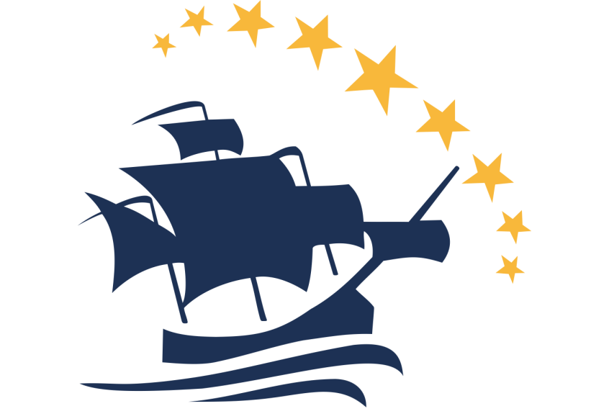

Vasco da Gama Movement
Annual Report for Europe Council - 2013

The VdGM Fund
Twenty two applications were received, a number which reflects the success of the programme that was launched last year. After careful selection, six candidates have been awarded with the bursary and will be aided to participate in the WONCA World conference in Prague. Nearly €4,000 have been assigned to the bursary winners, thanks to the generous donations of the Junior and Senior Association of Swiss General Practitioners (JHaS and SGAM respectively), to which all VdGM would like to extend its gratitude.
This great interest and number of applications is also evidence of the daunting financial problems that afflict our continent. Our Movement aims at intensifying the promotion of the importance of the VdGM Fund in Europe, and invites all National Colleges, Scientific Associations and Junior GP/FM Associations, to make donations in support of this cause.

The Awards and Prizes

The Junior Researcher Award 2013
The 2013 edition of the Junior Researcher Award has been granted to the following three junior champions in Family Medicine research:
- Nikki van Dessel (the Netherlands) for her proposal "Prognosis and perpetuating factors of Medically Unexplained Physical Symptoms (MUPS): a prospective cohort study";
- Joao Sarmento (Portugal) for his proposal "Clinical Information Integration Project";
- Pavel Vychytil (Czech Republic) for his proposal "Compliance and non-compliance with GP/specialty training requirements".
Four international reviewers (Professor Michael Kidd, Professor Eva Hummers-Pradier, Dr Greg Irving and Dr Tobias Freund) rated these outstanding research ideas to be meaningful for clinical practice and of high methodological quality. We would like to express our gratitude to each one of the jurors for their effort in evaluating the candidates, as well as to the networks of EGPRN, WONCA and WONCA Europe for their continuous support.

The Hippokrates and Claudio Carosino Prize 2012
Among the passionate and enthusiastic GP trainees who submitted their work, the 2012 winner of the Carosino Prize is Dr Marine Parmentier, 3rd GP trainee from France who visited Dr Angus Gallacher Practice in Buckie, Scotland, UK. On the other hand, the Hippokrates Exchange Prize goes to Dr Clara Vilavella Lizana from 3rd year GP trainee from Spain hosted by Dr Brigit Morre Pedersen in Århus, Denmark.
We would like to thank the Chair of WONCA Europe, Dr Tony Mathie, the Senior Hippokrates Coordinator and very creator of the Hippokrates Programme, Dr Per Kallenstrup, and Dr Jaume Banqué Vidiella executive member of EURIPA, who kindly accepted to be part of the panel that revised and selected this year applications.

The New Website
The VdGM has launched its brand new website under the WONCA Europe umbrella (www.vdgm.eu). The new platform offers us the flexibility to publish content of good quality and to become an engagement hub, as we work on integrating all of our social media connections with our content. An automated Hippokrates Exchange system has been developed to support all exchange procedures.

The World Preconference 2013
The Preconference will be carried out in Prague on 24th-25th June 2013, prior to the WONCA World Conference. The event is organized jointly by the Vasco da Gama Movement, the Rajakumar Movement, the Waynakay Movement, the Spice Route and the First Five Years in Family Practice in Canada.
Approximately 150 participants will join the Preconference this year. The format has been enhanced with the creation of parallel workshop activities.
Professors Roberts and Kidd will participate as our Visionary Speakers.

New EC Members
It gives us great pleasure to welcome new members in our Europe Council from Bosnia and Herzegovina, Croatia, Iceland, Israel, Latvia, the Netherlands and Turkey. Furthermore, we have sent invitations to all the Colleges, Associations and Junior Associations of the countries that have no representation in our Council, despite being members of the WONCA Europe.

A New Quality & Safety Theme Group inside VdGM
In December 2012, VdGM established a small working Group for Quality and Safety in Family Medicine in association with EQuiP. Christina Svanholm from Denmark has been appointed as the lead of this newly founded group, which is working to strengthen the relationship between VdGM and EQuiP with new initiatives.

International Exchange
As the number of doctors who would like to visit a Primary Care System outside the European Union is growing, the Exchange and Beyond Europe Groups of the Vasco da Gama Movement is putting a significant amount of effort on building connections with junior GP/FP associations.
Dr Ana Nunes Barata from Portugal has been appointed as the coordinator of the International Exchange Programme which is about to be launched in the WONCA World Conference.

International Development Programme for FM in Palestine
VdGM is participating in a programme that aims at the development of FM in Palestine. The programme has been launched by P. Wallace, S. Musmar and G. Feder and includes several meetings, courses and exchanges. VdGM will support the organisation and take part in the international course which is planned in November.

New Liaisons
New liaisons of VdGM have been appointed to EGPRN (Greg Irving), WWPWFM (Raquel Gomez Bravo), IPCRG (Ana Margarida Cruz) and EQuiP (Christina Svanholm).

Collaboration with ISfTeH
Both VdGM and WONCA Europe have been invited to work on a Memorandum of Understanding (MoU) with the International Society for Telemedicine & eHealth (ISfTeH), which will include a non-binding action plan for cooperation between them. The objective of such a MoU is to share resources, involve representatives in meetings, and support the technological needs and strategy of the associations.

New Account
Our bank account has been transferred under that of WONCA Europe, as it was decided in Vienna. This will help the treasurer as the bank account can remain in one country from now on. It also gives the possibility to use the legal identity of WONCA Europe in order to apply for funds or to participate in other programmes.

WONCA World Activities
These are our activities in the main conference:
- Future capacity for expert generalist care: A critical view of European training
- Leading and managing in your practice
- Training for family physicians: time to go global? A collaborative workshop of VdGM with EURACT
- Writing for publication: A joint VdGM, EGPRN, EJGP workshop
- The Hippokrates Exchange Programme: Everybody on board the VdGM raises the anchor
- The VdGM Hippokrates Exchange Programme: a Spanish and Italian perspective
- Shifting perspectives in healthcare: Becoming partners with patients
- Linking generations in general practice research – The Vasco da Gama Movement Junior Researcher Award 2013
- Gender Violence: A new approach
- Social media and mHealth now! Applications in primary care
- The importance of using Social Media in Rural Medicine
- Young family physicians/general practitioners – global initiative
- The RCGP First5 initiative – supporting new GP‘s in their first 5 years
- General Practice training across European borders
- Mini-Hippokrates experience in Croatia
- The Vasco da Gama Movement World Cafe for early stage researchers in general practice and family medicine
- The good, the bad and the ugly of healthcare reform: Achieving universal healthcare coverage in a cold economic climate

