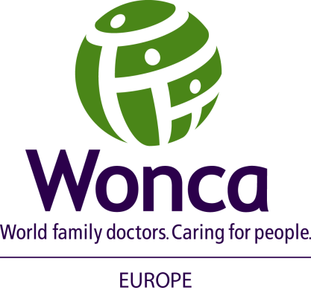

WONCA Europe London 2022 Legacy Statement

WONCA, as an academic organisation of General Practitioners/Family Doctors, demands the recognition of General Practitioners/Family Doctors as Specialists.
General Practice is the cornerstone of any patient centred, sustainable and cost effective health system. General Practitioners/Family Doctors become fully qualified after completion of a specialist training programme. As specialists, they are qualified to practice competence-based primary care in a quality and safe way.
Family medicine/general practice is an independent medical specialty, with its own competencies, quality standards, academic development, and research area.
Like other specialities, access to a specialist training programme occurs after completion of the country compulsory basic medical training (medical school and internship).*
Specialists in general practice / family medicine have a period of hospital-based as well as community-based training which is combined with specialist training for general practice/family medicine involving supervised work within a GP/FD officially approved training practice.
Like hospital-based specialities, there are full Professorships of General Practice/Family Medicine in universities and many European countries recognise the speciality of General Practice/Family Medicine as equal to other specialties.
WONCA calls upon all countries that do not have recognition of the speciality, to examine their own systems to promote and achieve the recognition of General Practitioners/Family Doctors as specialists in the field of General Practice/Family Medicine within the coming years.

